**Methods for Log Off of GAAM Sessions**

Goliath Application Availability Monitor currently only supports session log offs for Citrix launches when using Citrix Receiver v4.12 and newer.

In environments where this capability is unavailable (Microsoft RDS/VMware Horizon or older Citrix Receiver versions) there are other options for logging off the connected user session:

* **Utilizing the Startup Folder**: Log into a desktop session as the user-account, navigate to an Explorer window and enter shell:startup to open the user Startup folder. Create a batch file with the following contents:

@echo off  
ping -n 45 127.0.0.1 > nul  
logoff

* **Utilizing existing Logon Scripts:**The above commands can also be added to relevant logon scripts for the user above.
* **Utilizing Group Policy**: Configure GPO Settings to log a user off, apply them to the user that GAAM is using to log into the RDS or Horizon environment.  
    
  The following settings are located at User Configuration > Policies > Administrative Templates > Windows Components > Remote Desktop Services > Remote Desktop Session Host > Session Time Limits.  
  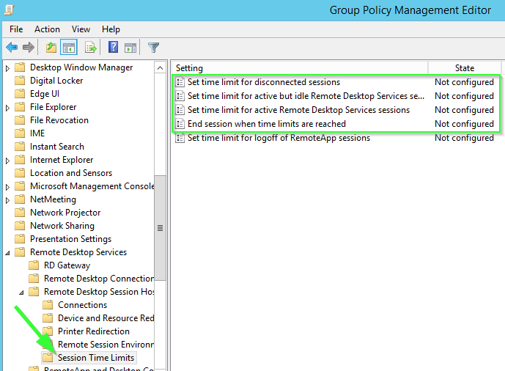  
  The top three options should be set to 1 Minute. It's also important to set the last option for "End session when time limits are reached" to "Enabled" so that sessions are ended for the configured user rather than just being disconnected.